Nuclear Magnetic Resonance

Qiong Wu
Lab partner: Daniel Gurevich

Georgia Institute of Technology
Oct 8, 2019

Abstract
In this lab, we investigated the fundamentals of pulsed nuclear magnetic resonance with the experiments using samples of mineral oil and wax. A sequence of RF pulses called π-pulses (180 degree pulses) or π/2-pulses (90 degree pulses) were applied to look for $T_{1}$ “spin-lattice relaxation time”, $T_{2}$ “spin-spin relaxation time” and “spin echoes”. Spin echoes were observed and the $T_{1}$ for mineral oil and wax were 15$±$15ms and 8$±$8ms, and the $T_{2}$ for mineral oil and wax were both 29$±$5ms. Comparing to other labs’ results, our $T_{2}$ has an error of 16% for mineral oil and 0% for wax. $T_{1}$has 100% error for mineral oil and unknown for wax.

Introduction
Nuclear magnetic resonance has two methods: “pulsed NMR” and “continuous-wave NMR”. Even though the methods are different, both techniques allows for the transferred energy between the sample of measuring device to be measured. In this experiment, we mainly focus on the pulsed NMR using the TeachSpin PS1-A pulsed nuclear magnetic resonance spectrometer to investigate the core principles of spin-spin and spin-lattice relaxation times. This experiment demonstrates the effects of perturbation on a system of magnetic dipoles within a solid or liquid.
By creating and manipulating a series of $π$ and $π/2$ pulses using the methods of pulse sequences, the spin-lattice ($T_{1}$) and spin-spin ($T_{2}$) relaxation times of the samples were measured and spin echoes were observed. We used samples of minerals oil and wax.

Theory
- Resonance Condition and Larmor Precession

When a nucleus of moment $μ$ is placed in a magnetic field $B_{0}$ it will experience a torque causing a change in the angular momentum following Newton's second law:
$\vec{τ}=\vec{μ}*\vec{B_{0}}=\frac{d\vec{I}}{dt}=\frac{1}{γ}\frac{d\vec{μ}}{dt}$
The relationship between the non-zero angular momentum $\vec{I}$and magnetic moment $\vec{μ}$of a nuclei is:
$\vec{μ}=γ\vec{I}$
Where$γ$ is the gyromagnetic ratio.
In an external field, the energy of these dipoles is:
E = -$\vec{μ}*B_{0}$=-$γℏl_{z}B_{0}$
For fermions from quantum mechanics, the energy between two states is, with the ground state split into two sublevels as I=1/2, Figure 1 shows the splitting of nuclear energy level:
$∆E= γℏB_{0}$=$ℏω_{0}$
Where $ω_{0}$ is the Larmor precession frequency.
Figure 1. splitting of nuclear energy level due to external magnetic field

- Relaxation Times
Due to the external magnetic field applied, the total magnetization on z-axis is
$$M_{z}= \sum_{i}{γℏm_{Ii}=\frac{1}{2}γℏ(N_{+}-N_{-})}$$
Where $m_{Ii}$ is the state of ith proton and $N_{+}$ and $N_{-}$ are the number of protons in the spin up and spin down state. When an RF field $\vec{B}$ is applied, some protons have their spin flip to align against B; these absorb energy from the RF field. Other protons experience a spin-flip to align with $\vec{B}$; these give energy back to the RF field. Thus, if the populations of the two sublevels were equal, $M_{z}$= 0 and no net energy would be absorbed from the RF field. The decay of $M_{z}$ to its its equilibrium (nonzero) value is due to energy exchanges between the proton magnetic moments and their local environments.
Once equilibrium is reached, there would be no net magnetization in the xy plane. And to get a spin on the z direction, we can simply pulse a transverse magnetic field in the xy plane. Thus, two relaxation processes can be observed during the non-equilibrium condition. First, the spins in the sample would return to equilibrium on the z direction. Second, the pulse applied would break the phase symmetry and as time goes on the phase would realign to equilibrium. Both processes go to equilibrium exponentially with a characteristic time constants. The constant that describes how the material’s atomic interaction within is called “spin-lattice” constant, and the constant that describes the spins interaction within the molecule is called “spin-spin” constant.
Since these signals of precessing and relaxing moments are magnetic, one way to detect the signal is to use a pickup coil to be orientated transverse to the static field as shown below in Figure 2. [1]
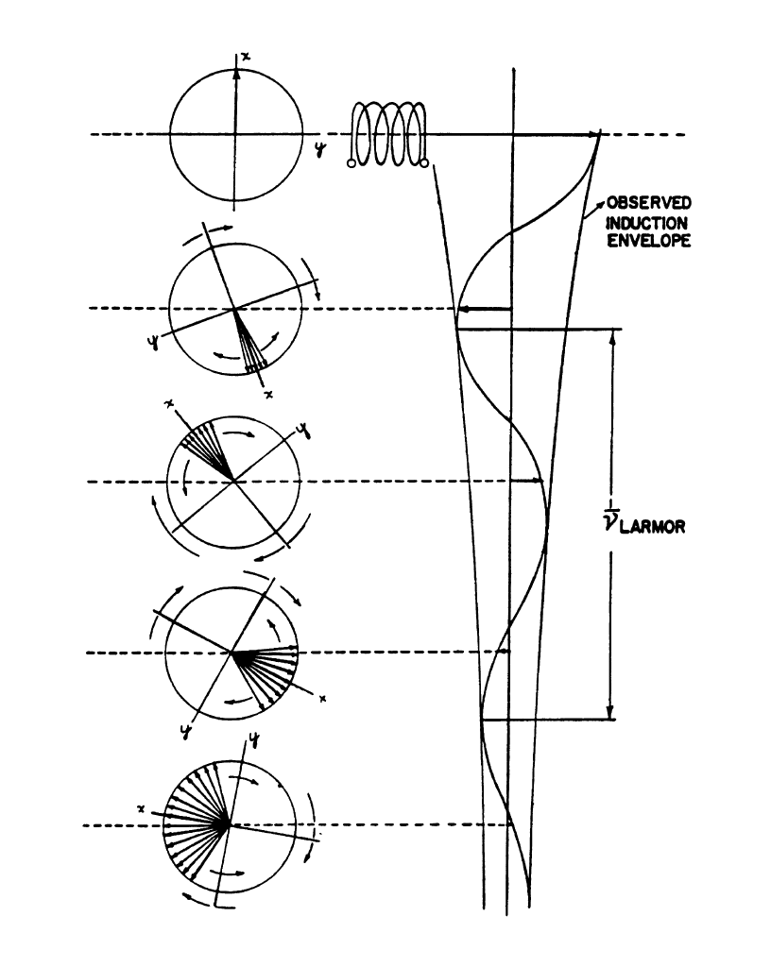
Figure 2. Induction signal measured by a pickup coil in the transverse plane following orientation of moments along the x-axis.
- $π$ and $π/2$ pulses sequences
In the pulsed NMR method, the RF excitation is applied to the sample in a series of short bursts, or pulses. The application of the RF field for a short time allows the applied torque to rotate the net magnetization M by a specific amount. The diagram of the PS1-A Pulsed NMR apparatus is as below in Figure 3.
Figure 3. Block diagram of the PS1-A Pulsed NMR apparatus
A $\frac{π}{2}$ pulse, for example, rotates the net magnetization by 90$°$ and the signal seen as a consequence is called the “free induction decay". The duration of a $\frac{π}{2}$pulse is equal to
the period of precession $t_{1}$ due to $\vec{B_{1}}$ divided by 4. From the relation $ω_{1}= γB_{1}$, we obtain the time for the $\frac{π}{2}$pulse:
$$t_{π/2}=\frac{1}{4}t_{1}=\frac{π}{2γB_{1}}$$

A $π$ pulse that has a longer duration flips the magnetization by 180$°$. The free induction decay signal immediately following a $π$ pulse is zero since there is no net transverse component of the magnetization available to induce such a signal.
The real utility of the pulse method comes from using a sequence of pulses. By such sequences, we can measure accurately and independently $T_{1}$ and $T_{2}$, and also compensate for the effects of field inhomogeneity.
- $Spin-lattice relaxation time and spin-spin relaxation time$
For the total magnetization, the function for the magnetization is as follows:
$$M(t)= M_{0}(1-e^{-\frac{t}{T_{1}}})$$
And as t approaches infinity, the magnetization goes to equilibrium. Therefore, for the oscilloscope FID signal trace it would show as since it measures the xy plane magnetization:
$$M(t)= M_{0}(e^{-\frac{t}{T_{1}}})$$
In order to measure $T_{1}$, a $\frac{π}{2}$ pulse is sent to rotate the spins of the sample onto the xy plane, then a $π$ pulse is followed in order to graph the height of the FID signal. The expected signal would look as follows. 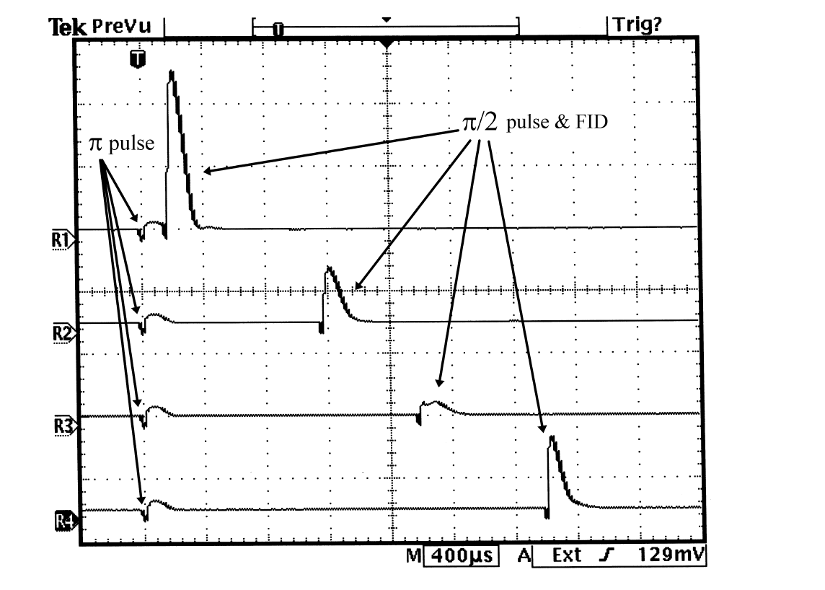
Figure 4. Oscilloscope traces showing zero-crossing method of determining $T_{1}$. The pulse occurs at the trigger point (T), and the FID signal from the $\frac{π}{2}$ pulse first diminishes as the delay time increases (traces R1 and R2), nearly vanishing at the delay time in the third trace from the top (R3), and then recovers at a later delay time (R4).

For the magnetization only on the xy direction, the magnetization equation for $T_{2}$ is
$$M_{xy}\left(t\right)=M_{0}e^{-t/T_{2}}$$
Since the spin-lattice relaxation and the spin-spin relaxation would happen at the same time, we apply series of pulses using the Carr-Purcell method which diffusion would be minimized. wherein many successive pulses followed after the initial $\frac{π}{2}$ pulse[2]. The result of such a sequence is a single scope trace showing many spin echoes. In effect, each echo is like a “start pulse" for the later pulse that creates a subsequent echo. The decay of the echo amplitudes follows an exponential curve, of time constant $T_{2}$ as long as the echo spacing is sufficiently close together relative to the diffusion time. An example of the scope trace with multiple echoes is shown below.
Figure 5. Oscilloscope trace showing many spin echoes. The small transients between the peaks are from the π pulses. $T_{2}$ can be measured from the decay of the envelope of the peaks

Data
For spin-lattice ($T_{1}$), we got $T_{1}$=15$±$15ms for mineral oil and 8$±$8ms for wax. For spin-spin ($T_{2}$), we got an estimate of $T_{2}$ to be 29$±$5ms for both mineral oil and wax. The Oscilloscope traces showing many spin echoes of mineral oil and wax are as follows, which both demonstrate a tendency of exponential decay as expected. 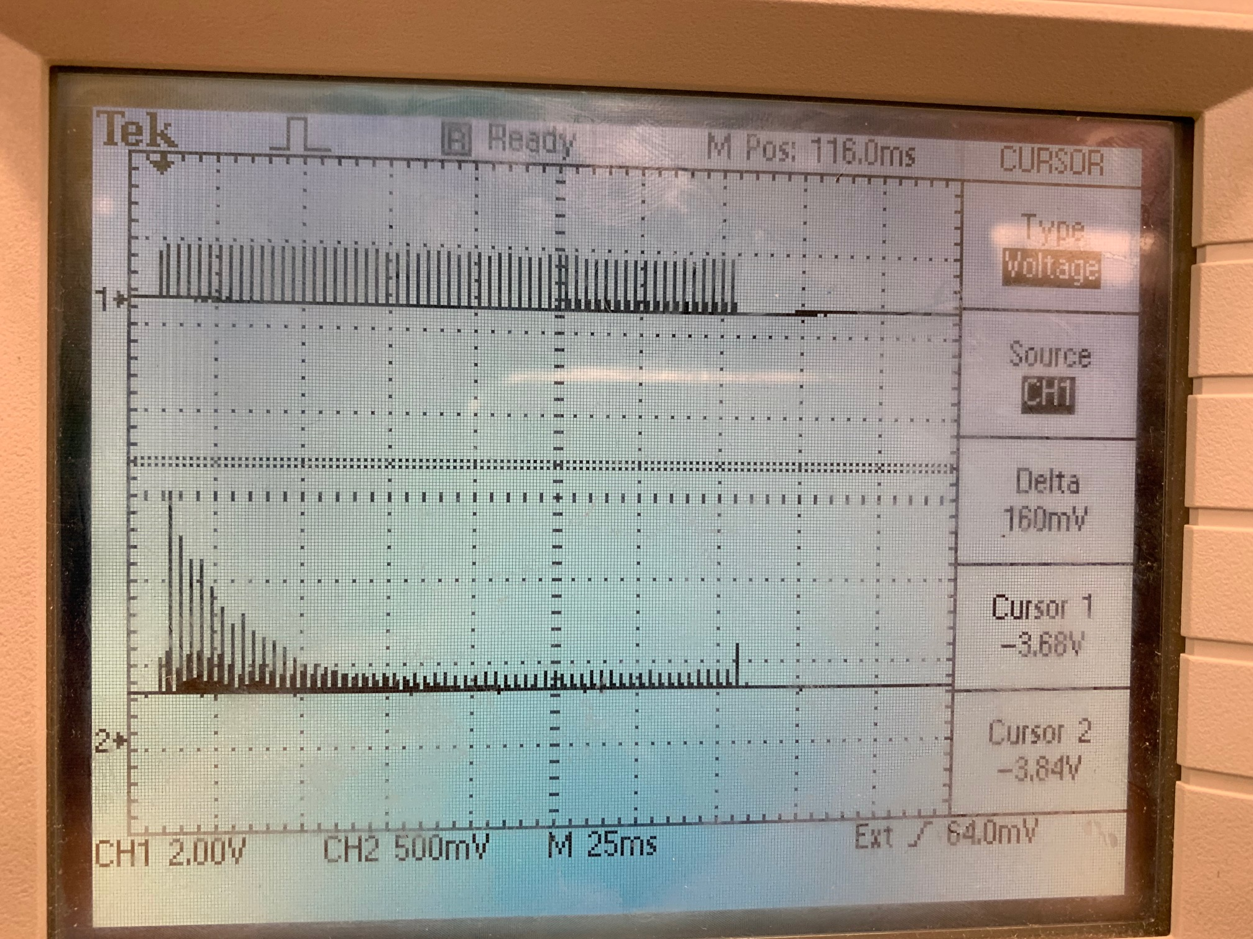
Figure 4. Oscilloscope trace showing many spin echoes of mineral oil. The small transients between the peaks are from the $π$ pulses.
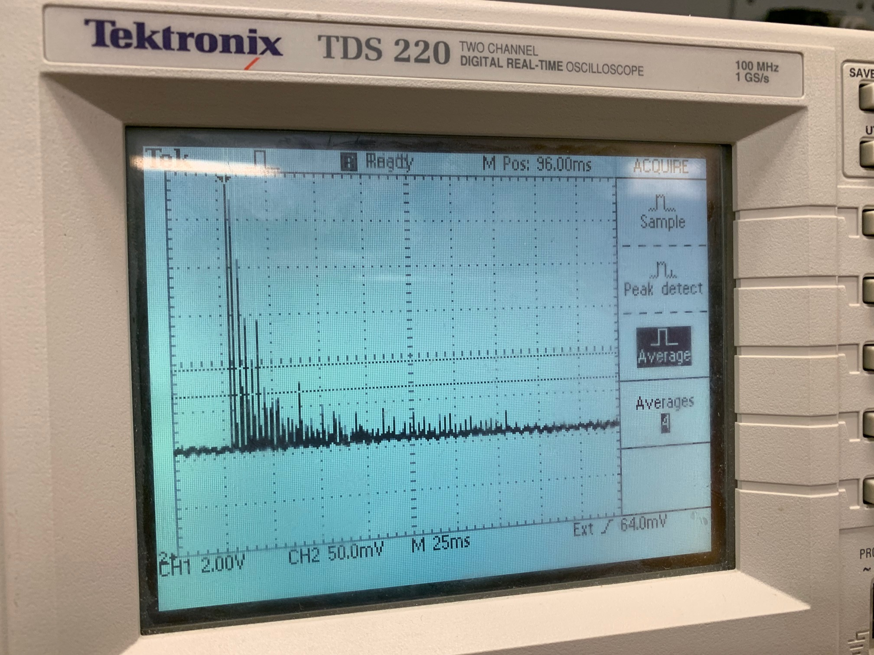
Figure 5. Oscilloscope trace showing many spin echoes of wax. The small transients between the peaks are from the $π$ pulses.

We used an estimation method to determine the relative magnetization measured by oscilloscope trace. We used the cursor function on the oscilloscope to measure the heights. And since the graph is pretty noisy, the errors seem pretty large.
Comparing to other people’s results, which says $T_{2}$ to be 25ms for mineral oil and 29ms for wax [3], our $T_{2}$ has an error of 16% for mineral oil and 0%. For $T_{1}$ to be 7.5ms for mineral oil, our error is 100%. Error for wax is unknown since $T_{1}$ for wax was not found.

Conclusion
The main purpose of the nuclear magnetic resonance is to investigate the internal structure of molecules by applying external magnetic field. In this experiment we used pulsed magnetic resonance sequences of $π$ and $\frac{π}{2}$ pulses to obtain the values of spin-lattice and spin-spin constants. The values were very inaccurate and had very large correction due to the instable reading on the apparatus. The reason for the large error mainly lies on that the reading fluctuates too much, possibly due to the transitioning magnetic field and inaccurate noises from the oscilloscope. Other than that, the experiment still successful helped us understand more about the fundamentals lies under the magnetic resonance which developed from quantum of the atoms to further investigate the material under an external field.

Reference
- Lab manual of advanced lab in Georgia tech
http://advancedlab.physics.gatech.edu/labs/Interferometry.pdf
- Carr, H. Y., and E. M. Purcell, Effects of diffusion on free precession in nuclear magnetic resonance experiments", Phys. Rev. 94, 630{638 (1954).
- Pulsed Nuclear Magnetic Resonance: Spin Echoes
http://web.mit.edu/8.13/www/JLExperiments/JLExp12.pdf

