MODERN INTERFEROMETRY

Qiong Wu
Lab partner: Daniel Gurevich

Georgia Institute of Technology
Sep 12, 201

Abstract
The primary purpose of this experiment was to understand the process of interferometry and its use in measuring the wavelength of light with superposition pattern of waves, and to calculate the index of refraction. First part of experiment we calculated the wavelength of the known He-Ne laser light. In the second part of the experiment we fill the chamber with air, Helium, and Argon to calculate the index of refraction. Comparing to the actual values, our experiments had a very small percent error. For the first experiment the He-Ne laser was calculated to be 625nm with an error of 1.25 %. And the index refractions for air, Helium, Nitrogen, and Argon were 1.00131, 0.9648, 1.00480, 1.00925, with errors of 0.103%, 3.522%, 0.45%, and 0.656%.

Introduction

The Michelson interferometer using a He-Ne laser is used in the experiment, with the light beam going into a beam splitting cube, splitting the beam into two beams. These two beams’ path are separated using mirrors and one of the beams goes through a gas chamber. As the two beams meet back up again, the combined beam is passed through a lens so that the magnified vision is shown upon a screen, and the intensity of combined beam is detected by the detector which connects to a computer.
As the two beams combine, if the path length difference of the two beam splitting arms is equal to zero or an integer number of wavelengths, constructive interference would show up. If the path length difference is half wavelength, destructive interference would show up. Thus, for the first experiment, the number of the passing fringes on the screen can approximate the path length difference. For the second experiment, the index of refraction for gases can be obtained as a function of pressure using the method of counting passing fringes, as the path length difference is originated from the gases refraction.

Experiment

- Apparatus
The basic idea of interferometry is the principle of superposition. When two waves of the same
frequency combine, we can look at the new wave for information about phase differences of the original two waves. If the two original waves have no difference in phase, they interfere
constructively and we see an increase in intensity of their light, if the two original waves have a phase difference of π, they perfectly cancel each other in destructive interference and we see
nothing. A diagram of a simple interferometer is shown below in Figure 1.
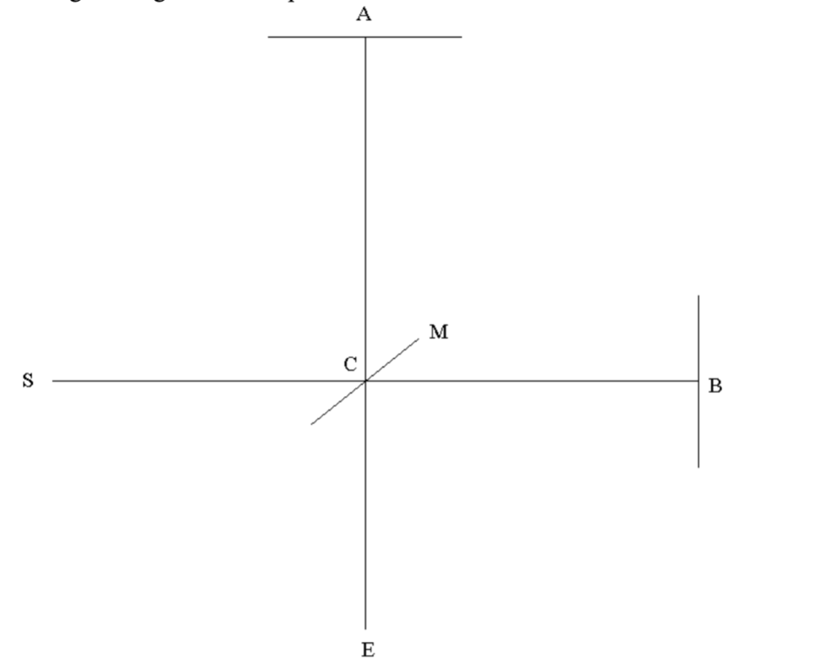
Figure 1. Simple interferometer

The figure below shows the experimental setup which includes the location of instruments and the path of the beams of light that goes out of the He-Ne laser.
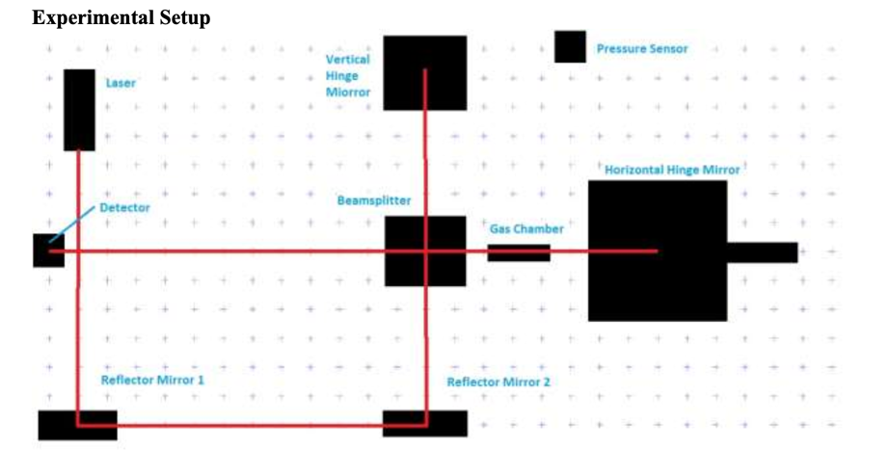
Figure 2. Experiment setup

- Theory
A source laser at point S emits monochromatic light that then hits surface M at point C. Surface
M is a beam splitter which splits the laser light into two beams, one in the direction of A and the
other in the direction of B. At points A and B are mirrors which reflect the beam back to surface
M, which recombines the two beams and then reflects the beam to point E, the observer. If the
two beams are in phase, the observer will see an image no different than if he simply observed
the laser without any reflectors or mirrors. However, if the two beams are out of phase the
observers will see patterns of destructive interference.
In this experiment, we use two ways to induce the phase difference for the two beams. For the first part we change the length of one arm using a motor in a uniform speed so that the new beam travels in a longer distance. Thus, we can observe the phase difference as the motor is on. In the second part of the experiment, we slow down one beam of light by adding mediums seperately, which were Argon, Helium, and Nitrogen in our case. Each type of medium has an index refraction of n. And the wavelength varies according to the equation $λ=\frac{λ_{0}}{n}$, where $λ_{0}$is the wavelength of light in vacuum. At relatively low pressure, the index of refraction is linearly proportional to the pressure.

Performance

- Part I: Measuring the Wavelength of Light
In order to measure the wavelength of the laser, we changed the distance between the beam splitter and the horizontal hinge mirror using a motor, so that the distance change would be constant and steady. The resulting reading is connected to the computer so that we can read the intensity as it varies with time. The motor worked in a rate of 0.1mm/min. Since the distance of one fringe is equivalent to one wavelength of the light. The wavelength can be calculated by counting the fringes the screen detected in this period of time using the formula below:
$λ=\frac{distance traveled by motor}{time of osicllations}$(1)

- Part II: Measuring Indexes of Refraction of Gases

In order to measure the indexes of refraction of gases in the chamber, we first need to use the vacuum pump to pump out the air inside. Then we let air/Helium/Argon/Nitrogen to flow into the chamber either using open nod or a syringe. The intensity related to pressure is recorded by the computer. We can count for the number of oscillations between constructive and destructive interferences. Initially there were $m_{i}=\frac{2d}{λ_{i}}$ wavelengths in the chamber, where d = 10cm is the chamber’s length. At the end of the recording, there are $m_{f}=\frac{2d}{λ_{f}}$ wavelengths in the chamber. Taking the difference and we get:
$n_{f}-n_{i}=\frac{Δmλ_{0}}{2d}$ (2)
And n = 1 for vacuum.

Analysis
- Part I: Measuring the Wavelength of Light
We got a measurement of 80 oscillations in 30 seconds. 30 seconds = ½ min and in ½ min, the motor travels 0.05mm. Using equation (1), we obtained the wavelength $λ=625nm$. For a red He-Ne laser that have wavelength 632.8nm, we had an error of 1.23%. The graph of intensity versus time is shown below in Figure 3.
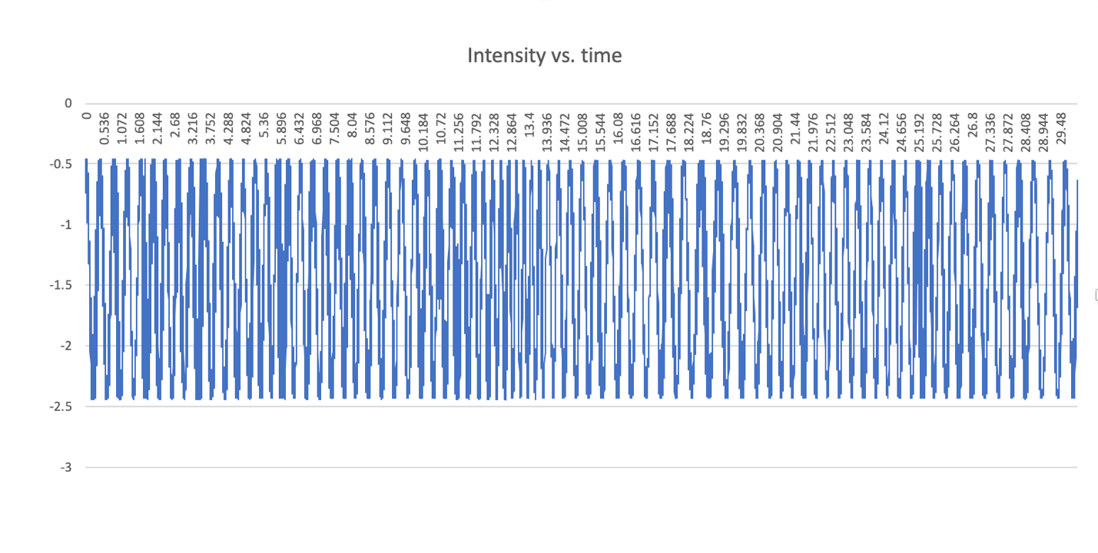
Figure 3. Intensity vs. Time for wavelength of light

- Part II: Measuring Indexes of Refraction of Gases
In this part of experiment, we measured indexes of refraction for air, helium, argon, and nitrogen. The corresponding graphs for intensity versus pressure for these four gases are as shown below in figure 4-7: (the beginning and end of the graphs is cut out for more accurate calculation)
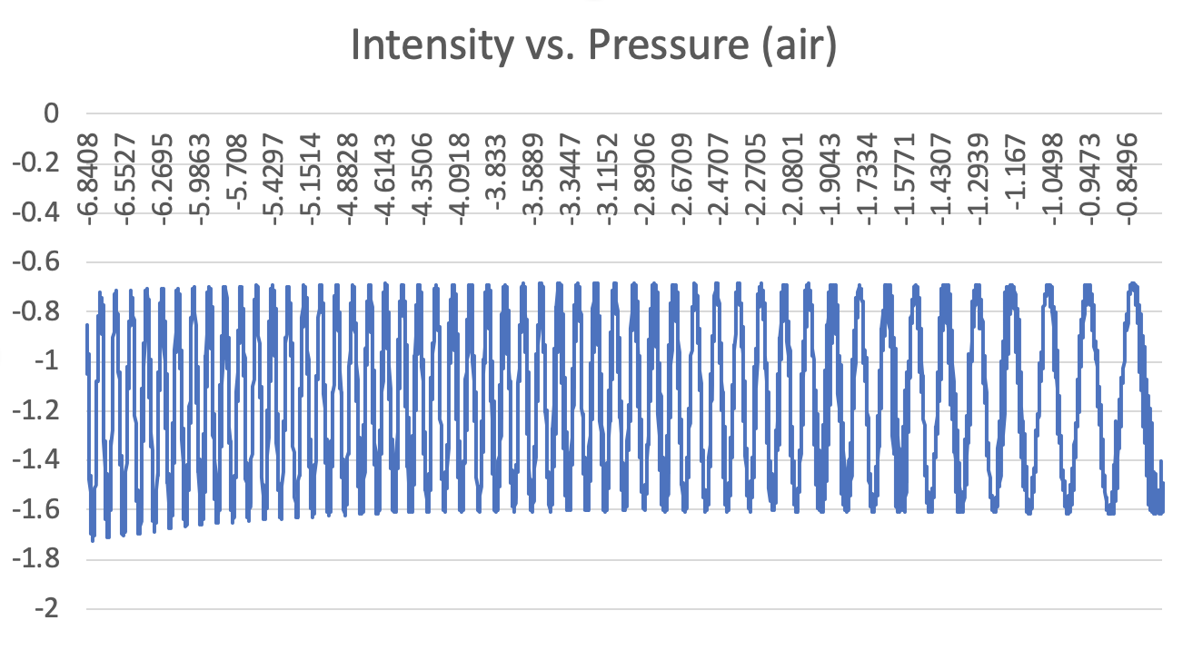
Figure 4. intensity vs. pressure for air

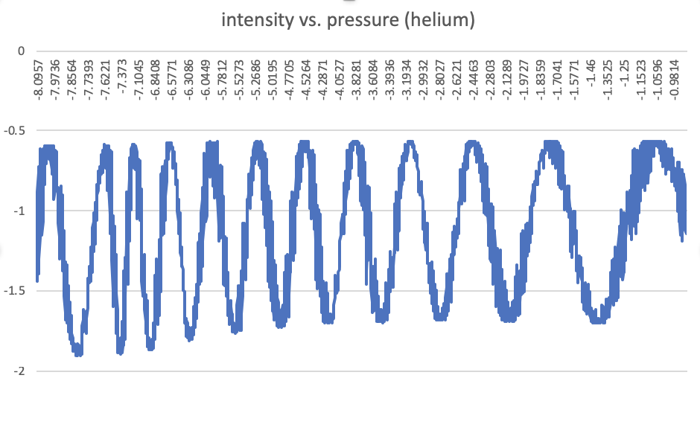
Figure 5. intensity vs. pressure for helium

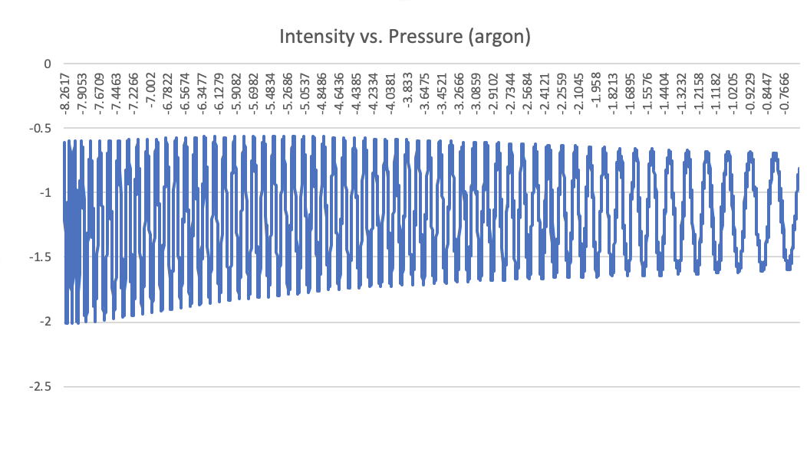
Figure 6. intensity vs. pressure for argon

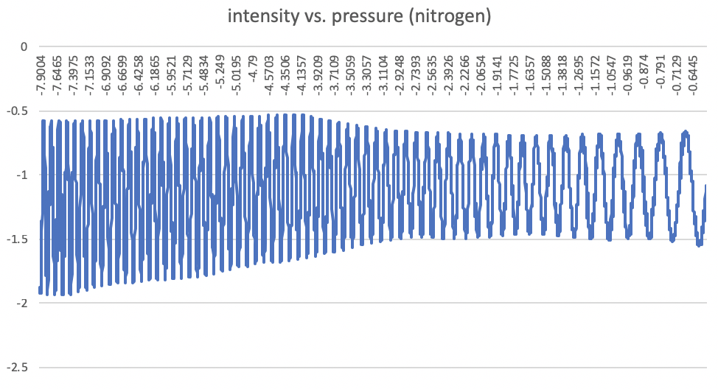
Figure 7. intensity vs. pressure for nitrogen

Using equation (2), we can get the indexes for air, helium, argon, and nitrogen is:
$n_{air}=1.00131$ (error% = 0.103%)
$n_{helium}=0.9648$(error% = 3.52%)
$n_{argon}=1.00925$(error% = 0.656%)
$n_{nitrogen}=1.00480$ (error% = 0.45%)

Conclusion
The main purpose of the modern interferometry experiment is to demonstrate the principle of superposition for light wave. In the experiment we used the interference pattern of light passing through different mediums (air, helium, nitrogen, argon) to calculate the wavelength of light and the indexes of refraction of the mediums. The values were pretty accurate with $n_{air}{,n}_{argon}, n_{nitrogen}$ all within 1% error. The reason for the slightly higher percentage error for helium may be due to that it was our first time in these trials to add gas in and the process was not as smooth. The data points for helium are not as ample as the other trials, which may cause the error to increase. Another source of error includes that the compared values of indexes of refraction has a lower temperature than room temperature, which may cause the percentage error to be slightly bigger. Another source of error may be that the interference patterns are so sensitive that when people walking by it may get interfered by it.

References

- Lab manual of advanced lab in Georgia tech
http://advancedlab.physics.gatech.edu/labs/Interferometry.pdf

- Refractive index of gases
https://refractiveindex.info

