Physics 4321 Lab Report II

Two Slit Interference

Qiong Wu

Lab Partner:

Hannah Price

Abstract
In this lab, we would examine the wave-particle duality of light through two experiments using slit interference. We would use laser and bulb separately as light sources to see the double and single interference patterns. Strong evidence would show that indeed one photon at a time reach the photomultiplier that detect the photon. Both patterns from laser and one photon showed clear diffraction pattern, demonstrating both particle and wave nature of light.

Introduction
Is light particle or wave? This is a hot debated question in physics since long. The earliest argument probably came from Isaac Newton and Christian Huygens, when Newton claimed that light behave like particles and move in straight lines and Huygens claimed that light is indeed a wave that has all the properties of waves.
Then in 1801, Thomas Young performed the first double slit experiment, showing distinct interference pattern that diffracts light just like water wave. The diffraction pattern was the first clue for the world that light might work as a wave. The light as wave theory was so widely believed around 1800s. And Faraday and Maxwell who were very interested in electromagnetic showed that electromagnetic field exist propagating disturbance, which corresponds to the wave characteristics of light.
However, that was not the end of the story. In 1905, Einstein found photoelectric effect, which is the emission of electrons when light shines on material. He believed that the photoelectric effect would be better explained by understanding light as small particles, or photon. Thus, the question became from picking one answer from two to developing two answers at the same time. Further when quantum mechanics came to light, its theory contained that all matter has the particle-wave duality.
In this experiment we examined the single and double slit diffractions using laser and then one photon at a time. We observed clear patterns of light behaving like waves in interference patterns for the laser experiment. For the photon experiment using light bulb, we have clear claim to show that indeed one photon was detected at a time. However, due to the difficulty in handling the equipment, we did not get a matching pattern for single slit diffraction that corresponds to prediction model, instead, we got double slit patterns as well. But nonetheless, the results could still show the particle and wave nature of light.

Theory
The equation for single slit interference is:
I (θ)=I_{m}(sin α/ α)² Eq(1)
And α equals:
α= π*α*sin(θ) / λ Eq(2)
Here I_{m} is the central maximum intensity, α is the slit width, and λ is the wavelength of light, θ is the angle which is measured relative to a line drawn at the center of the single slit.
The equation for single slit interference is:
I (θ)=I_{m}(sin α/ α)² *cos(β)² Eq(3)
And β is:
β = π*d*sin(θ) / λ Eq(4)
Here, d is the distance between the centers of the two slits. Each slit has the same width, α.
In order to have an expression for intensity as a function of x, we see the relation in Figure 1 and get:
θ = arctan [(x – q)/L] Eq(5)
Here, L is the distance from double slit to the detector slit, q is the position of central maximum of either slit.
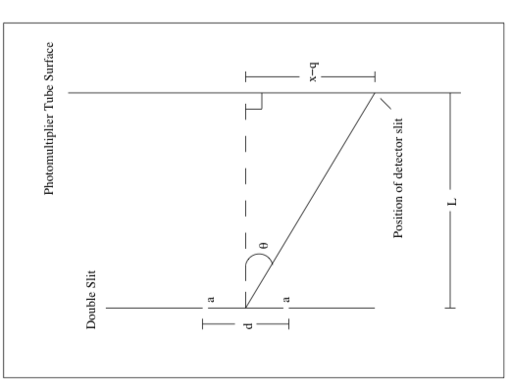
Figure. 1: This diagram shows the geometry of the parameters in Eq (1) through Eq(5).

- Experiment Using Laser Source
In the first experiment we shoot a laser light through the closed up Teach Spin system in Figure 2 in appendix and record the current-to-voltage converter reading for the double slit, and the two single slits blocking the other slit. The background reading is 0.007V. The result is as follows in Figure 3, with laser of manufacture wavelength 670 +/- 5nm. Background reading already deducted, error bar lies within scale.
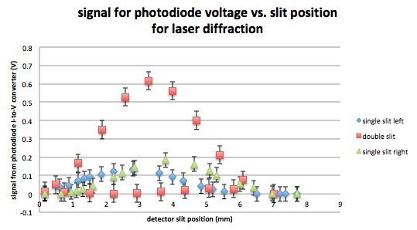
Figure. 3: Light Intensity vs. Position for Laser double slit and single slits Interference Patterns
The maximum intensity for double slit pattern is about three to four times the maximum intensity for the two single slit patterns. The reason for the almost quadruple relationship is that according to Eq(1), if the light doubles its source, the intensity at its maximum would quadruple due to the square factor.
In observation of Figure 2, we can see that the maximum for double slit occurred at 3.27 ± .01 mm and the two first minimums for double slit interference occurred at 2.92± .01 mm and 3.64± .01 mm. On these two points they almost corresponded to the positions of where the two maximums of the two single slits experiment. The reason for the minimums is due to destructive interference of the waves from double slit interference according to Eq(1).

- Experiment Using Light Bulb
In the second experiment we opened a bulb light to let it shine through the closed up Teach Spin system in Figure 2 and record the photon count reading for the double slit, and the two single slits blocking the other slit. Before that, we recorded a set of ten data points with maximum intensity to calculate the standard deviation of the fluctuation of the photomultiplier reading. We got a standard deviation of 30.76 count/s. And the data point has the average of about 1x10³ count/s.
First, let us examine if one photon reached the photomultiplier indeed. Since photomultiplier is rated at 4% efficiency, the actual photon arrival rate is 25 times greater, 25x10³ photons/second. The length of the apparatus in Figure2 from the laser source to the photomultiplier tube is about 1 meter. A photon travelling from the source to the photomultiplier tube with the speed 3x10⁸ is about 3 nanoseconds. Our photon arrival rate of 25x10³ photons/s indicates that the photon takes 4x10⁻⁵ second, or 4000 nanoseconds, to arrive. Therefore, we could say that there is 3 nanoseconds out of 4000 nanoseconds for our photon to be on the air. This can be used to approximate that in 99.925% of time, there is no photon in the air, whereas in the 0.075% of time, there is one photon in the air. Therefore, we can say with confidence that indeed one photon reaches the photomultiplier at one time due to the dim light bulb.
After determining that indeed one photon pass through the slit each time, let us coming back to the photon count reading for the double slit and the two single slits patterns. The set of data for the three interferences is as follows in Figure 4.
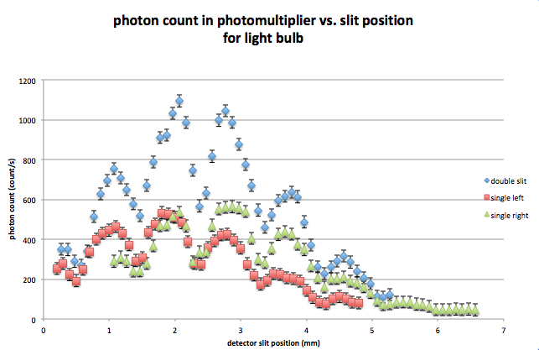
Figure. 4: Photon Counting Data for Single and Double Slit Configurations of a bulb source

Here the maximum occurred at 2.07± 0.01 mm. The first minimums occurred at 1.80± 0.01mm and 2.87±0.01mm. The maximum values for the single slit diffractions were separately 533±30 Hz and 560±30 Hz, while the maximum for double slit was 1094±30 Hz. We could say that the “single slit diffractions” were not actually single slit diffractions. Since according to Eq(1) and Eq(3), the intensity of the maximum for single slit should be ¼ of the intensity of maximum for double slit in theory. Also, we can see that in the two “single slit” diffraction patterns, there appeared local minimums around 1.5±0.1mm, 2.3±0.1mm, 3.2±0.1mm, and 4.1±0.1mm. These local minimums showcased the destructive pattern of the double slit interference. The evidence that further prove that these two “single slits patterns” were actually a less intensified version of our double slit set up was that all the local minimums mentioned above terribly corresponded to the local minimums of the double slit pattern.

Conclusion
In the two experiments of using laser and light bulb to determine double and single interference patterns, there were two things going not as predicted: the maximum positions for double slits for the two sources and the diffraction patterns for bulb source in general.
The maximum of double slit interference for bulb experiment was 2.07± .01 mm which was away from the maximum of double slit interference for laser experiment which was 3.27 ± .01 mm. This showed that even we tried to move the equipment as little as possible, there was still movement of the aligning that made our maximum go array. Otherwise, if the two light sources were from the same spot, the position of the double slit diffraction maximum should be the same.
During the second one photon experiment, in order to get a better single slit pattern, we tried to move the slit blocker around a lot and did several other trials. However, we either got a very similar result or no signal at all. The possible reason for the failure to see a predicted single slit pattern is that we were actually really close to completely block the slit but did not really so that they were still double slit pattern.
Another really important possible reason for the failure of one photon experiment might be that there was interfering light due to the moving of maximum. If we look at the minimums of double slit pattern in Figure 4, we shall see that the minimums did not go all the way to zero which they should be for a good destructive interference according to Eq(1) and Eq(3). The local maximums for the double slit pattern also did not look very pretty since the two second maximums were separately 1046±30 Hz and 756±30 Hz, which was a huge gap. The best fit line, on the other hand, does not correspond to Eq(3) very much also. According to the signs above, one possible reason for the wiggly patterns was that due to the misalignment from the perfect setup from the laser experiment, there existed a gap somewhere that interfered the patterns.
If were to improve the experiment, we would go back to realign the apparatus to make sure they can work properly. Even this way we could not tell if the maximum would be shifted, we could at least make sure that the slits alignment was proper and to testify if the single slit pattern would behave as predicted.
Overall, the clear diffraction patterns for both the laser source and the bulb source can indicate strongly the wave nature of light. And even the patterns did not behave as how we expected to be in the bulb experiment, we still managed to explore the particle-wave duality nature of light based on the claim that only one photon got to the photomultiplier at one time and the pattern still showed clear diffraction pattern.

Reference
- R. Feynman, Quantum Electrodynamics (Oxford University Press, 1988), pp. 78
- R. Feynman, The Character of Physical Law (MIT Press 1967) pp. 128.

Appendix

Figure 2.
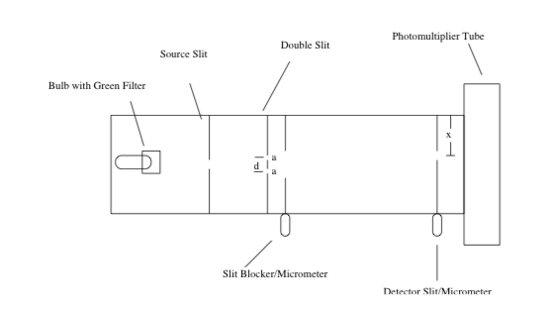
Figure 2. This diagram shows the basic setup of the double slit apparatus from Teach Spin

Table 1.
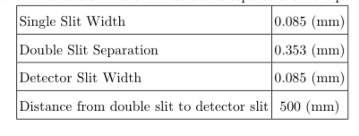
Table 1. Geometric Parameters. The slit widths and separations were provided by Teach Spin.

