Zeeman Effect

Qiong Wu
Lab partner: Daniel Gurevich

Georgia Institute of Technology
Oct 28, 2019

Abstract
Zeeman Effect, which was predicted by Hendrik Lorentz and observed by Pieter Zeeman, is the effect that produces splitting patterns of atomic energy levels from an excited species in the presence of a strong magnetic field. The primary purpose of this experiment was to understand the Zeeman effect and to observe the transverse and parallel patterns, and to calculate the value of the Bohr Magneton. In this experiment, the spectral line observed from Zeeman Effect is the green line of mercury at 546.1nm. First part of experiment we observe and record the patterns of transverse viewing under different magnetic field and different polarization angles. Triplet splitting was observed under strong magnetic field in transverse viewing. Magnetic field was measured using a hall probe. In the second part of the experiment we observe the patterns of parallel viewing under different magnetic field and different polarization angles. Doublet splitting was observed under strong magnetic field in parallel viewing. We then calculated the value for Bohr Magneton from the generated e/m value 1.297*${10}^{8}$c/kg and found to be 1.256*${10}^{-23}J/T$. Comparing to the actual values, e/m value has percentage error of 35.45%, and $μ_{B}$ has a percentage error of 35.39%.

Introduction

Zeeman Effect, which was predicted by Hendrik Lorentz and observed by Pieter Zeeman, is the effect that produces splitting patterns of atomic energy levels from an excited species in the presence of a strong magnetic field. The splitting of energy levels allows for more energy level transitions to occur. In this experiment, the spectral line observed is the green line of mercury at 546.1nm. From quantum mechanics point of view, the Zeeman effect splits the energy level into 2l+1 separate levels. Since the actual electron energy level transition follow the selection rule, the total nine different transitions under strong magnetic field make three rings because some transitions overlap.
The different patterns between transverse viewing and parallel viewing under different magnetic fields can be explained by the different $σ$ and $π$ components of light. $π$ lines correspond to radiation that polarized parallel to the magnetic field and $σ$ lines correspond to radiation that polarized perpendicular to the magnetic field. By turning the polarization filter, we can observe that the $π$ line is linearly polarized perpendicular to the two $σ$ lines. For transverse viewing, the middle $π$ line is polarized parallel to the field and the other two $σ$ perpendicular to the magnetic field. For parallel viewing, polarization occurs with opposite rotation for the two $σ$ components. Thus, the reason for the doublet splitting is that only one or the other of the $σ$ lines can be observed due to rotational angles.
The Zeeman effect can also be used to calculate the Bohr Magneton constant $μ_{B}$, which stands for the angular momentum of an electron in the lowest orbital. The relationship of the change in energy levels and the magnetic field strength is related as $∆E=μ_{B}*B$ in a linear manner. The Bohr Magneton can be calculated from the splitting of transverse viewing and from the measured magnetic field strength.

Theory

- Quantum background
An electron in an atom is characterized by quantum numbers, which completely describe it’s energy {n l $m_{l}$ $m_{s}$}:
- principal quantum number n defines the electronic shell, n = 1 . . . $n_{max}$;
- orbital angular momentum quantum number l describes the sub shell (0 = s-orbital, 1 = p-orbital, 2 = d-orbital, 3= f-orbital, etc.), l = 0...n−1, |L| = $\sqrt{l(l+1)}ℏ$
- magnetic quantum number (projection of angular momentum) $m_{l}$ describes the specific orbital within that sub shell $m_{l}$ = −l... $m_{l}$...l
- spin projection quantum number ms describes the electron spin with angular momentum vector s and quantum numbers s = ±1/2, |s| = $\sqrt{s(s+1)}ℏ$
For electrons, as for all fermions (particles with half-integer spin), the Pauli exclusion principle is valid: In an atom, there cannot exist a pair of electrons with an identical quadruple of quantum numbers. The total angular momentum of an atom can be estimated as vector sum of the individual electronic contributions. The total spin S and the total angular momentum L are given by: S = |$\sum{m_{s} }$|; L = |$\sum{m_{l} }$|.
There is a number of possibilities to combine $m_{s}$ and $m_{l}$. Hund’s Rules helps to find the ground state:
- completely filled sub shells do not contribute to J
- partially filled sub shells follow the Pauli exclusion principle and:
1. as much as possible electrons have parallel spin (S → max)
2. electrons occupy states to maximize L
- J = L ± S, “+” for sub shells which are more than half filled and “−” for less than half filled sub shells
The atomic states are specified using $n^{2S+1}L_{J}$.
The equation for Bohr magneton, $μ_{B}$, is:
$μ_{B}$= $\frac{eℏ }{2m_{e}}$= 9.274 · ${10}^{-24}$J/T
The spin generates a magnetic moment, $μ_{B}$ which is double of that of the orbital angular
momentum, $μ_{L}$:
$μ_{L}$ = −$g_{l}μ_{B}$L and $μ_{S}$ = −$g_{s}μ_{B}$S $g_{s}$ ≈ 2
Then the total angular momentum is: $μ_{J}$ = $g_{j}$ · $μ_{B}$J, with scaling factor $g_{j}$, the LANDE factor to be:
$g_{j}$=1+[J(J+1) − L(L+1) + S(S+1)]/[2J(J + 1)]

- Anomalous Zeeman Effect
The general, also known as anomalous, Zeeman effect is present for atoms with non-zero total spin. Since electronic spin can have only two values, +1/2 and −1/2 , all atoms with an odd number of electrons have a non-zero spin. The orbiting electrons in the atom are equivalent to a classical magnetic gyroscope. The torque applied by the field causes the atomic magnetic dipole to process around B (Larmor precession). The external magnetic field therefore causes J to process slowly about B. L and S meanwhile process more rapidly about J due to the spin-orbit interaction, see Figure below. The speed of precession about B is proportional to the field strength.
Fig 1. Addition of angular moments
The orbital and the spin magnetic moments do not interact independently with the small external magnetic field. Rather, the orbital and spin magnetic moments interact with each other in such a way to form a combined magnetic moment $μ_{j}$ that interact with the external field. The orbital motion of the electron results in a magnetic field at the location of the electron. The spin magnetic moment of the electron interacts with this field and couple the spin and the orbital magnetic moments together. The magnitude of the field seen by the electron is approximately 1 T. If the external field is higher than the internal than the spin and the orbital magnetic moments decouple and interact independently with the external field.
The angular momentum combine to form a total angular momentum J = L + S. J is the angular momentum with a definite projection along the z-axis , see Fig. 1. The magnitude of J is $\sqrt{J(J + 1)}ℏ$. The projection a long the z-axis of the total angular momentum is the quantum number $m_{j}$:
$J_{z}$= $L_{z}$ + $S_{z}$ = ( $m_{l}$+ $m_{s}$) $ℏ$ = $m_{j} ℏ$
The angular momentum and the magnetic moments are quantized along the magnetic field, which is here chosen in z-axis. So for a multi-electron atom the expression for the energy shift or the additional potential energy in the external field is given by:
U = −$μ_{J_{z}}$· $B_{z}$ =${ g}_{j}μ_{B}m_{J}B_{z}$
Without a field, the states with different $m_{J}$ have equal energy. Increasing B, the states split and more transitions are possible. The distances between neighboring energy levels amounts to ${ g}_{j}μ_{B}B_{z}$. The spectral line observed is the green line of mercury at 546.1 nm, which splits into nine components (see Figure 2, where the lines on the bottom correspond to the transitions represented by the arrows above).

Figure 2. spectral line of mercury
- Quarter wave plate
Some crystalline materials can have different indices of refraction associated with different crystallographic directions. A common situation with mineral crystals is that there are two distinct indices of refraction, and they are called birefringent materials. The quarter wave plate is composed of such material.
A quarter wave plate consists of a carefully adjusted thickness of a birefringent material such that the light associated with the larger index of refraction is retarded by 90° in phase (a quarter wavelength) with respect to that associated with the smaller index. The material is cut so that the optic axis is parallel to the front and back plates of the plate. Any linearly polarized light that strikes the plate will be divided into two components with different indices of refraction. One of the useful applications of this device is to convert circularly polarized light to linearly polarized light and vice versa (Figure below). This is done by adjusting the plane of the incident light so that it makes 45° angle with the optic axis. This gives equal amplitude ordinary and extraordinary waves. When the ordinary wave is slower, it will fall behind by 90° in phase to the extraordinary wave, producing linearly polarized light.
Figure 3. quarter wave plate application
- Fabry-Pérot Etalon
A Fabry-Perot interferometer works in the same way as an interference filter. It is composed of two glass plates covered each with semi-reflective coating. The incoming light beam is partially transmitted through the semi-reflective mirror and partially reflected as shown below. The separated light beams coming out of the interferometer differ not only in intensity but also in phase. This phase shift will cause them to interfere with each other. If the out-coming light from the interferometer is focused by a lens the resulting interference pattern looks like shown below.
By measuring the distances ∆R and dR between the interference lines and Zeeman splitting lines, one can calculate the difference in wavelength between atomic transition lines and Zeeman lines as given by the equation:
$$∆λ=\frac{dR}{∆R}\frac{λ^{2}}{2d}=\frac{2dR}{∆R+∆R^{'}}\frac{λ^{2}}{2d}$$
Figure 4. light path through interferometer

Experiment

- Part I: Transverse viewing
In order to view the transverse viewing of the pattern, we first rotate the potentiometer clockwise to increase the magnet current until an easily visible splitting of the circular fringes is seen on the monitor. Then we rotate the polarizer mounted behind the lens until a pattern like Figure 5b is observed. This shows the full range of Zeeman split lines emitted in the transverse direction.
Figure 5a Figure 5b
Continue to rotate the polarizer until the triple fringes shown in Figure 5c are seen. These are the strong π polarized components that will be used for measurement. Rotating the polarization filter by a further 90° yields the pattern shown in Figure 5d. These fringes arise from the σ polarized components and are noticeably less intense.
Figure 5c Figure 5d
Measure the magnetic field using a hall probe. Then we use computer program to draw rings in order to generate the value of e/m by the following equation:
$$\frac{e}{m}=\frac{2πc}{dB}\frac{1}{(M_{2}g_{2}-M_{1}g_{1})}\frac{D_{k}^{2}-D_{k-1}^{2}}{D_{k}^{'2}-D_{k}^{2}}$$

- Part II: parallel viewing
In order to view the parallel viewing of the splitting, we first turn off the magnet current. Then we remove the iron core from the right hand pole piece of the magnet by pulling out on the thumbscrew. We then rotate the lamp in its socket to direct the light from the window through the hole in the pole piece and insert the quarter wave plate into the hole in the pole piece. Next, release the magnet yoke arresting screw on the side of the magnet power supply and swing the entire magnet assembly through 90° .View the pattern on the computer monitor.

Results and Analysis
- Part I: transverse viewing
The pattern we got for triple fringes is as follows in Figure 6a below, and the pattern we got for rotating the polarization filter by a further 90° yields the pattern in Figure 6b. The image capture of screen with the drawn lines and computer generated e/m value is shown in Figure 6c, with a measured magnetic field to be 1T.
Noticeably, the separation between the rings increase linearly with the magnetic field. Also, by turning the polarization filter, we can observe that the $π$ line is linearly polarized perpendicular to the two $σ$ lines.

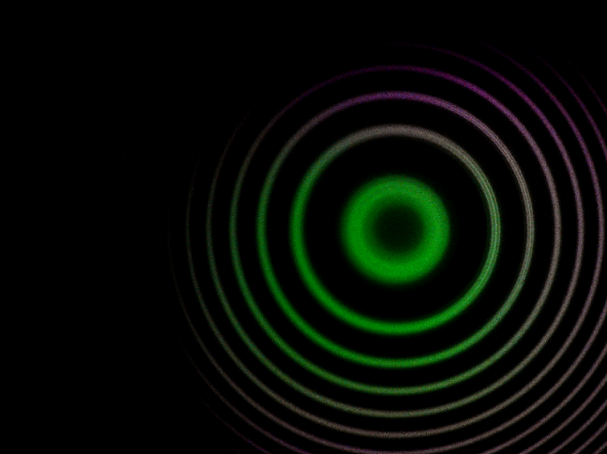
Figure 6a. experiment triple fringe viewing in transverse viewing
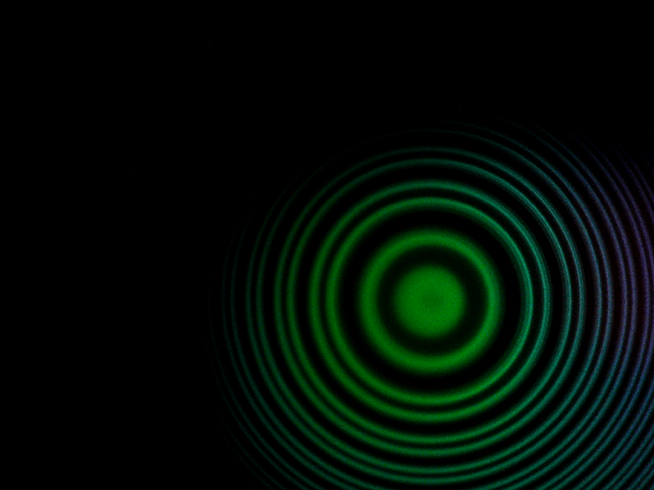
Figure 6b. experiment triple fringe viewing in transverse viewing with polarization filter

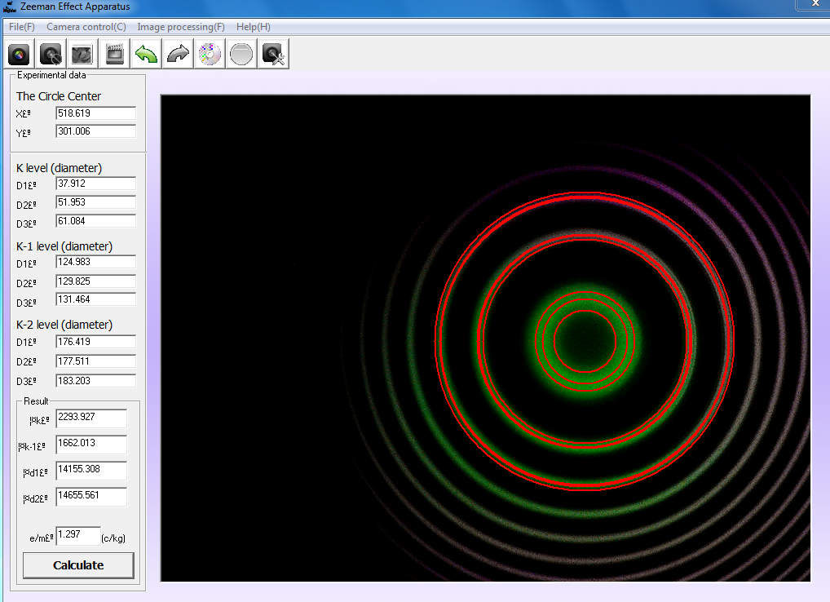
Figure 6c. experiment triple fringe viewing in transverse viewing image capture with drawn lines

The calculated value for e/m is 1.297*${10}^{8}$c/kg. Comparing to the accepted value 9.58*${10}^{7}$c/kg, the percentage error is 35.45%.
Calculating the Bohr Magneton value using the equation $μ_{B}$= $\frac{eℏ }{2m_{e}}$ and the obtained e/m value, $μ_{B}$= 1.256*${10}^{-23}J/T$. Comparing to the accepted value 9.274${*10}^{-24}J/T$, the percentage error is 35.39%.

- Part II: parallel viewing
In this part of experiment, polarization occurs with opposite rotation for the two $σ$ components. Depending on the position of the polarization filter (0° or 90°), only one or the other of the displaced lines can be observed. The other two lines are circularly polarized in opposition. Thus, doublet splitting is observed because only one or the other of the $σ$ lines can be observed due to rotational angles.
Unfortunately we did not record the viewing pattern in this section.

Conclusion
The main purpose of Zeeman Effect experiment is to observe the effect that produces splitting patterns of atomic energy levels from an excited species in the presence of a strong magnetic field. In the experiment we observed the splitting patterns of Mercury light under polarization in transverse and parallel directions. We then used the distances between splitting in transverse direction to calculate the value of e/m and Bohr Magneton. The values were 1.297*${10}^{8}$c/kg with a percentage error of 35.45% for e/m, and 1.256*${10}^{-23}J/T$for $μ_{B}$ with a percentage error of 35.39%. The reason for the slightly high percentage error may be due to that the drawing of lines on computer was not so accurate. Another source of error includes that we only measured the magnetic field using hall probe once and thus may be an inaccurate reading.

References

- Lab manual of advanced lab in Georgia tech
http://advancedlab.physics.gatech.edu/labs/ZeemanEffect.pdf

- Lab manual of advanced lab in Linkoping University
http://www.ifm.liu.se/courses/tffm08/dloadsExfys/Lab24_Zeeman.pdf

