Physics 4321 Lab Report I
Wave Particle Duality

Qiong Wu

Abstract
In this lab, we would examine the wave-particle duality of electron through three experiments, mimicking the break through experiments done by the great minds before. In the first experiment, we examined the wave nature of electrons by diffracting them through a crystal structure using deBroglie relation and Bragg Law. In the second experiment, similar to one of J.J. Thomson’s Helmholtz experiments, we created an electron trajectory within a magnetic field from a Helmholtz pair and obtained the e/m ratio. For the third experiment, we intended to conduct an x-ray diffraction experiment that would show both particles and waves nature of electrons. For safety reason, the third x-ray diffraction experiment would be conducted with thought experiment through calculations and analysis to demonstrate how crystallography works.

Introduction
It was not until the 20th century when scientists realized that electrons could behave both as particles and as waves. Up to 20th century, J.J. Thomson discovered that electrons beams were consisted of particles of electrons and did multiple fields’ related experiments on electrons trajectories. Then de Broglie postulated the bold idea that particles could also behave as waves. According to Bohr’s model, the permitted electron orbits happen when the angular momentum is an integral multiple of ħ. Broglie suggested that the standing waves in the circular orbit should also apply Bohr’s quantization rule. Using the conservation and quantization of momentum and quantization of wavelength:
Eq 01. L = mvr = nħ
Eq 02. 2πr = nλ
de Broglie reaches the deBroglie equation combing the two above:
Eq 03. λ = h/p
Since the wavelength of a typical electron beam of 100 eV is small as 1.225Å, with Å to be 10⁻¹⁰ m, it was very difficult to conduct an experiment to diffract to such small wavelength.
In early 20th century, Davisson and Germer proved the wave nature of electrons through an electron diffraction experiment at a Ni₁₁₁ surface. The fact that particle can work as wave no longer make the position of the particle definite as in classical physics. Instead, the electrons would have the probability and uncertainty nature of wave mechanics. The door to particle-wave duality was opened; quantum mechanics finally came to light.

A. Electron Diffraction Experiment
- In the first electron diffraction experiment, our goal was to observe the diffraction produced by the electrons, calculate the wavelength given interference pattern, and to determine the crystalline structure based on calculations. The set up of the experiment is shown below in Figure A1.
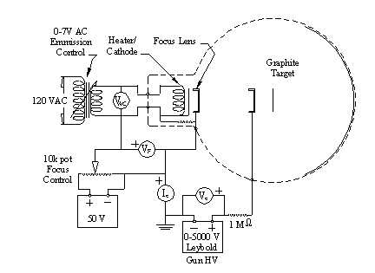
Figure A1. Schematic drawing of the electron diffraction system showing electrical connections.

Electron beams are emitted through the cathode heated by the 120 AC supply. The focusing voltage would make the beam go on focus and strike the graphite target that is in the middle of the tube. Since the graphite sample is composed of periodic arrangement of carbon atoms, it was used to work as a diffraction grating here. According to Bragg Law, the electron wave would diffract into certain angles:
EqA1. 2d*sin θ= λ_{o} (n=1,2,3…)
Since the tube is in high vacuum, the electrons do not lose energy while hitting gas atoms. According to deBroglie’s relation which states that electrons can have wave nature, the wavelength of the diffracted electrons is given by:
EqA2. λ=h/p
where h is planck’s constant and p is momentum.
For electrons accelerated through a potential eV=p²/2m, the wavelength would be given by:
EqA3. λ=h/√2eVm
- We turned on focus supply to 50 V and adjust heater voltage to 6V and waited one minute for cathode to heat. Then we turned on high voltage and adjusted high voltage slowly while noticing that the anode current I_{e} does not exceed 0.2mA so that the electron beam would not burn the tube. Two diffraction rings appeared on the fluorescent screen. We adjusted the voltage and recorded the diameter of the diffraction rings as a function of accelerating voltage in 15 voltage steps from 1500V to 5000V with one step of 250V.
- We recorded width of beam for error estimation, heater voltage, focus voltage, and anode current as a function of accelerating voltage. In order to calculate the scattering angle 2θ, We also measured the diffraction ring arc lengths, s , the target-to-screen distance, l , and the dome radius, R from Figure A2 below.
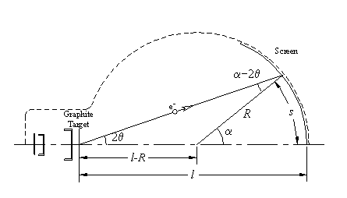
Figure A2. Scattering geometry of beams through graphite target on the tube
A detailed calculation of scattering angle 2θ is given in Calculation A1 in Appendix using trig identity and arc length relationship. Find electron velocity using conservation of kinetic energy and potential energy, mv²/2=eV. The recorded and calculated data is in Table A1 in Appendix.
- Combining EqA1. Bragg Law and EqA3. deBroglie’s relation, we can get an equation that eliminates θ, observing rings for spacing between two planes, d₁ and d₂:
EqA4. sinθ =(h/d√8me) × (1/√V)
For both rings, we plotted sinθ vs. 1/√V in Figure A2 and Figure A3 below, hoping to find a fit straight line due to deBroglie’s relation.
sinθ vs. 1/√V for d₁
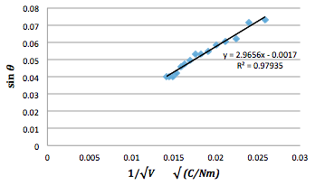
Figure A1. Graph for sinθ vs. 1/√V for d₁ (error bar lies within scale)

sinθ vs. 1/√V for d₂
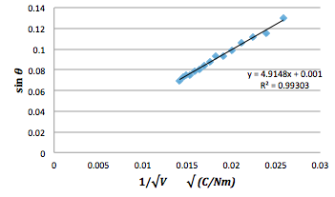
Figure A2. Graph for sinθ vs. 1/√V for d₂ (error bar lies within scale)

Our resulting lines are very close to linear with R²=0.98 for FigureA2 and R²=0.99 for Figure A3.
- Since d₁ and d₂ not only represent the diffraction separation distance, but also the spacing of atoms in the crystal sample, we can use the slope obtained in Section A4 to calculate d₁ and d₂.
EqA5. d=h/(slope×√8me)
d₁ calculated to be 2.070 ± 0.002 Å and
d₂ calculated to be 1.249 ± 0.002 Å, with Å to be 10⁻¹⁰ m.
Since graphite has hexagonal lattice structure, the atomic spacing a_{o} can be obtained using:
EqA6. d₁ = 3 a_{o} /2
EqA7. d₂ = a_{o} √3/2
a₀₁ calculated with d₁ is 1.380 ± .001 Å and
a₀₂ calculated with d₂ is 1.442 ± .002 Å.
B. Electron Charge/Mass Ratio Experiment
- For the charge/mass ratio experiment, we aim to observe the particle behavior of the electrons and to calculate the electron charge/mass ratio by sending a stream of electrons through a nearly uniform magnetic field, created by a Helmholtz pair. The electron trajectory would be visible since the tube has a low partial pressure of argon, causing electrons to collide, excite, and decay to give out the visible light. The set up of the lab is as follows in Figure B1.
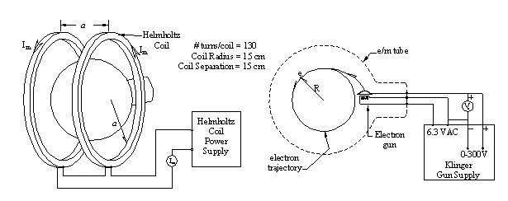
Figure B1. e/m tube and Helmholtz coil electrical connections

- After setting up as shown, we turned on the Helmholtz supply and the gun supply, and then slowly increase the Helmholtz coil current until we could see a closed circular electron trajectory. We then recorded five sets of diameter of the trajectory with different accelerating voltage and Helmholtz coil current. The data recorded is shown in the first three columns below in Table B1.
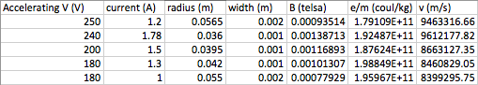
Table B1. Measurements and calculations table in electron charge/mass ratio experiment

- We then calculated the magnetic field using the equation for the magnetic field of Helmholtz supply in the middle axis:
Eq B1. B = 8μ₀NI_{m}/(5a√5)
The e/m values in the fifth column of Table B1 were calculated using Newton’s second law for a circular orbit, magnetic force on electrons, and equal relationship of the kinetic energy of electron and electrostatic potential of the gun.
Newton’s second law: F_{B}=mv²/R
Magnetic force on electrons: F_{B}=evB
KE=eV: eV=mv²/2

Combing these three equations above,
Eq B2. e/m=2V/B²R²
Note that we are using non-relativistic equation here. It would be acceptable because notice that in the final equation of e/m, there is no velocity value. Thus, the ratio of e/m would not depend on if we choose to use relativistic or non-relativistic method. The result of our e/m value is 1.91×10¹¹ ± 0.08 Coul/kg.

C. X-Ray Diffraction Experiment
- For the X-ray diffraction thought experiment, we aim to explore crystallography while examine the wave-particle duality of x-rays. We had the equipment set up as shown below in Figure C1. The x-rays are produced from an x-ray tube, which works by striking electrons at Target One and the decelerated electrons would convert into x-ray radiation, and then the x-rays are collimated and strike Target Two. Target Two is in the middle of a cylinder holder, as the x-ray hits Target Two, the x-ray is diffracted at an angle 2θ, leaving the film that wraps around inside the cylinder marks. We can therefore measure the displacement of marks on the film later on.

Figure C1. The sketch of set up for x-ray diffraction thought experiment.

In our first thought experiment, Target One would be iron (Fe) and Target Two would be NaCl. The following table Table C1 provides binding energy for Fe.
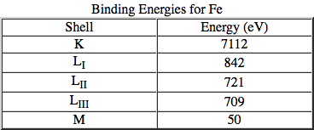
Table C1. Binding energies for Fe in different shells
- Because the x-ray diffraction contains both crystal diffraction, where the x-ray beams hit Target One and create x-ray through deceleration, and electron emission, where the x-ray emits photons from Target Two, this experiment shows both the wave nature and particle nature of x-rays. Through multiple collisions, the loss of energy of the electrons would produce the continuous spectrum of x-rays known as white radiation. The maximum energy lost determines the shortest wavelength according to Planck’s equation, stating that the energy of a photon is proportional to its frequency and thus inverse to its wavelength.
Planck’s equation E = h c / λ = eV
Thus, the accelerating voltage that we apply on the electron gun would directly influence the wavelength produced. The highest voltage available would therefore reach the shortest wavelength limit.
- Not only the highest voltage would affect the wavelength, so does the lowest possible voltage. According to Bohr’s assumption and later on the flame test that confirmed that energy level is quantized for moving from one level of energy to the other, the lowest possible voltage has to ensure that the electron would have enough gained energy to jump from one level to the other, otherwise no reaction would occur and thus no wavelength would be observed. The scenario of “absorption edges” which happens when sharp discontinuities occur in the absorption spectrum is also due to quantized energy. When the energy of an absorbed photon corresponds to an electronic transition or ionization process, the discontinuities would appear. In this experiment, in order to produce K series x-ray for Fe as desired for the experiment, the minimum accelerating voltage would be calculated using Planck’s equation E = h c / λ for the longest wavelength using information of Table C1 in section C1. The calculated minimum accelerating voltage would be 1.03x10⁻²⁵ V.
- Let us take a closer look at the short wavelength limit for the x-ray experiment. As discussed earlier in section C2, the maximum energy lost determines shortest wavelength limit. We can use this conclusion from Planck’s equation combining with E = e V, reaching that
E = h c / λ =e V
By transforming the equation, we get
h / e= V λ / c
Because photon is particles of light, the speed of light is always the same, we can calculate the value of h/e with the minimum wavelength calculated from Table C1 and highest Voltage obtained.
- Since x-ray is very dangerous to deal with, we would calculate the expected distance s from the zero mark, which is at 2θ=0, from information of Table C1 and Bragg Law.
Bragg Law 2d*sin θ= λ_{o}
For our target, NaCl has a cubic crystal structure with a lattice constant of 5.64 Å. Distance d1 is half of the lattice constant due to that there is two kinds of atoms in the crystal. The ratio of d₁/d₂ would be √2 because of the cubic crystal structure of NaCl. The calculations for the distances on the NaCl film in as follows in Table C2.
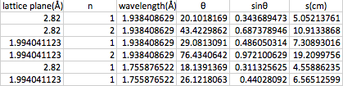
Table C2. Measurements and calculations in x-ray diffraction experiment using NaCl
- With the calculations of distances in Table C2, we then indexed these lines on a past diffraction pattern of NaCl that was taken before in our lab. The line pattern from the film was reproduced and attached in Figure7 in the next page. One line was given values at s=5.05cm, with known d1, n=1, known K_{a}. We measured the experimental data of s for all the rest lines according to scale with the line that has given all values to compare with our theoretical result. The measured values on the graph were 4.56cm, 5.05cm, 6.38cm, 7.05cm, 10,21cm, and 17.61cm from bottom to top lines. The theoretical values we obtained from calculations were 4.59cm, 5.05cm, 6.57cm, 7.31cm, 10.91cm, and 19.23cm. We can see that the values were pretty accurate according to lower energy level and the reading went a little bit off when it gets to higher level energy with the energy level at (d₂, n=2, K_{a}).
- Using the same technique as calculations in Table C2 in section C5, we then created a similar calculation for graphite (carbon) target. The plane distances d₁ and d₂ are used from experiment A in section A4, which approximately form a hexagonal structure with a ratio of 1.66. The final calculations are in the table below Table C3. The lines were then drawn and indexed to scales on the next page on Figure 7 next to the NaCl diffraction pattern.

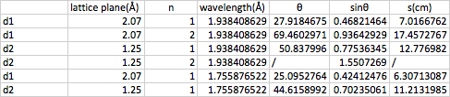
Table C3. Measurements and calculations in x-ray diffraction experiment using graphite
Notes that the fourth trail was error since the sinθ value was out of range to get a corresponding θ value. This is possibly due to the erroneous calculation of d₁ and d_{2.}
- Let us take a look at Bragg Law that we used to do calculations:
2d*sin θ= λ_{o}
For an actual experiment, we can obtain sinθ by measuring the s value and calculating using the relationship between angle and arc length. We can also obtain the λ value using Planck’s equation combining with the element’s level energy information. Thus, the only variables would be the plane distances d1 and d2. After obtaining d1 and d2 from the experimental values and calculations described, we can then use the d1/d2 ratio to determine the crystal structure in this powder diffraction experiment. (For example, cubic has d1/d2 ratio of √2 hexagonal has d1/d2 ratio of √3)
- To get a better idea of energy ranges and appropriate wavelength, Table C4 below contains the velocities and wavelength for six more radiations with x-rays, electrons, and neutrons with different energy.
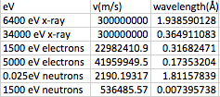
Table C4. Velocity and wavelengths for different types of radiation

Noting that each of the radiation energy corresponds to some significant meanings for our lab or physics in general. For first entry, 6400 eV x-rays, it corresponds to the characteristic iron x-rays photon energy. The second entry, 34,000 eV x-rays, corresponds to the highest voltage in Experiment three that gave the NaCl pattern, which means that the corresponding wavelength 0.36 Å stands for the shortest wavelength according to the discussion in section C4. As for the third entry and fourth entries, 1500 eV electrons and 5000 eV electrons, they indicate the range of voltages applied in Experiment A. From the fifth and sixth entries, 0.025 eV neutrons and 1500 eV neutrons, we can see that the wavelength we got from 0.025 eV neutrons is 1.81 Å while the wavelength from 1500 eV neutrons is 0.0074 Å. Thus, we can see that in order to get the wavelength to be of the order of inter-atomic dimensions, which is in the order of Å, the neutrons must have very low energy level to reach that dimension.

Conclusions
- In the first electron diffraction experiment, electron beams are emitted through heated cathode and diffracted on graphite target onto tube. We recorded the radius of the rings diffracted and all the parameters needed and did best-fit linear lines for the data of sinθ versus 1/√V for the two atomic spacing d₁ and d₂.
d₁ calculated to be 2.070 ± 0.002 Å and
d₂ calculated to be 1.249 ± 0.002 Å, with Å to be 10⁻¹⁰ m.
a₀₁ calculated with d₁ is 1.380 ± .001 Å and
a₀₂ calculated with d₂ is 1.442 ± .002 Å.
  - Comparing to the published result of atomic spacing for graphite a₀ = 1.42 Å, the measurements for this electron diffraction experiment were pretty accurate for the larger ring d₂ with a percentage error of 1.5% and not as accurate for the inner ring d₁ with a percentage error of 2.8%. The possible reason of this difference in accuracy for inner ring and outer ring is that the radius for the inner ring was extremely difficult to see. The human eye could make much mistake especially when the light was too dime to see. The light rings, on the other hand, also had widths that would affect the accuracy of our measurements.
  - Since d₁ and d₂ represent the atomic spacing between atoms within the graphite, we can use the ratio d₁/d₂ to check if the structure of graphite is hexagonal or cubic. For hexagonal structure, the ratio would be √3 and for cubic structure, the ratio would be √2. Using the values of d₁ and d₂ from section A5, we obtained d₁/d₂ = 1.66, which is closer to √3 with a 4% error, comparing to a 17% error for the √2 value. This means that graphite corresponds more to a hexagonal structure in our experiment. Possible reason for lack of accuracy in the atomic spacing ratio may trace back to the inaccurate atomic spacing due to measurement defects. It is also possible that the graphite substance is not so pure after long time sitting there so that it is not purely hexagonal structure inside.

- In the second electron/mass ratio experiment, a stream of electrons was shoot through a vacuum tube that has a nearly uniform magnetic field produced by the Helmholtz pair. We recorded diameters of the electron trajectory of five combinations of accelerating voltage and coil current and calculated e/m ratio using Newton’s law, conservation law, and the magnetic force on electrons. The result of our e/m value is 1.91×10¹¹ ± 0.08 Coul/kg.
  - Comparing to the published value of 1.76×10¹¹ Coul/kg , our result had a percentage error of 8%. Possible reason for our defected result is that when we read the radius of the electron trajectory, it is very difficult to see using the reflection ruler and the human eyes can easily make mistake. Also, the electron beam has a width of around 1×10⁻³~2×10⁻³ m. The width can affect our reading of the radius and thus leading the final calculation to defect. And I noticed that when we did the reading, we all did the reading according to the inner radius. I tried adding the width of the beam to the radius of the electron beam, the e/m ratio becomes a beautiful 1.79×10¹¹ ± 0.08 Coul/kg, with a percentage error of only 2% comparing to the published value of 1.76×10¹¹ Coul/kg.
  - Thus, if to do this experiment again, I would change the way I read my reading by including some part of the width in my calculation so that the reading of radius does not become too small for only reading the inner circle of the trajectories.
- In the third x-ray diffraction thought experiment, we imagined the setting to be a ray of electrons striking a Fe target, producing x-ray though decay that got collimated and sent onto target Two (NaCl for the first case). The x-ray is then diffracted onto a film that was wrapped around the film holder and left marks to record the distance and angle. Using Planck’s equation, Bragg’s Law, and de Broglie relation, we got to calculate the theoretical distance from point zero, which is at 2θ=0. Comparing the theoretical distance to an old experimental data on a slip, we got to testify that the calculations were correct.
  - After a broad look of energy and wavelength of electron, x-ray, and neutron diffraction from Table C5, let us review some similarities, usage, and advantages of each of these three kinds of diffractions. In comparison, X-rays and electrons are scattered by the electrons and neutrons are scattered by atomic nuclei. Thus, when one electron is on a hydrogen atom, for example, it is very hard to use x-ray or electron diffraction to find the electron. But in a neutron diffraction experiment, since the hydrogen nucleus scatters neutrons strongly, it is easy to find the electron on the hydrogen atom. Similarly, only neutron diffraction and not electron or x-ray diffractions can determine the magnetic structure of materials due to the nature of its diffractions. When measuring the thickness of thin films, on the other hand, we can only use electron diffraction, since it does the least penetration.
  - Electron diffraction is the most easily available one since electron can be easily produced by cathode tube. X-rays diffraction is the cheapest and the most widely used method to do an experiment. Neutron sources are very limited and expensive on the other hand, most neutron diffraction is used in big research lab for thermal neutrons in nuclear reactor, for example. The advantage of x-ray diffraction includes that x-ray diffraction structure analysis can be applied for single crystal and the measurement is under atmosphere pressure. The advantages of electron diffraction include that crystal structure and parameters can be calculated, as shown in section C8, and can handle nano-size crystals. The advantages of neutron diffraction include that it cannot be absorbed by crystal, so that we can use neutron diffraction to do research on heavy atoms that strongly absorb x-rays.

References
Books:
- ‘Modern Physics’, Richtmyer, Kennard & Cooper
- “X-rays in Atomic and Nuclear Physics’, N.A. Dyson
Websites:
- Crystal Structures - http://www.ill.fr/dif/3d-crystal
- Snow Crystals - http://www.snowcrystals.com
- Synchrotrons-Modern x-ray sources - http://www.esrf.fr
- Ratio - https://www.siue.edu/~mnorton/Ratio.pdf
- Difference Between Electron Neutron and Xrays- https://www.slideshare.net/BHOLURAMSWAMI/difference-bw-electron-neutron-and
- Wave Particle Duality -https://www.ece.gatech.edu/sites/default/files/documents/stepup/2006/wave-particle-duality.pdf

Appendix
- Calculation A1
The angle α subtended by the diffraction rings is given by:
α = s/R
From the geometry of Fig. A2, the scattering angle can be related to α, l and R:
sin(α-2θ)/(l-R) = sin2θ/R
Using the trig identity sin(α - 2θ) = sinα cos2θ - cosα sin2θ, the scattering angle is given by:
tan2θ =sinα/(l/R+cosα-1)
- Table A1
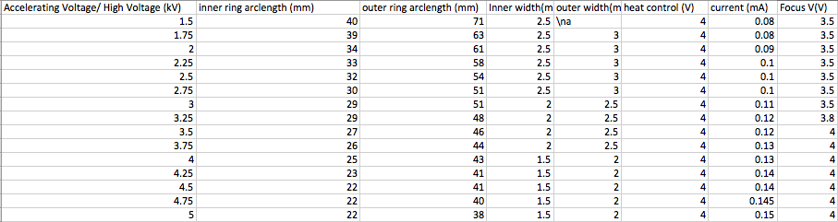
Table A1. Recorded data for experiment electron diffraction experiment

